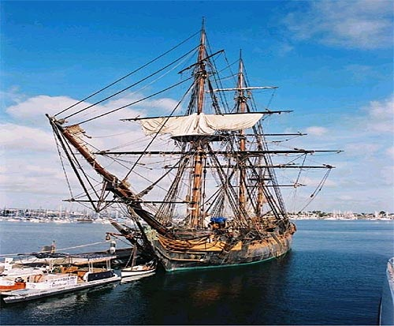
VISAKHAPTNAM
A PEEP INTO THE MARITIME HISTORY OF THE CITY OF DESTINY
K R A Narasiah

FOREIGN NOTICES
FOREIGN NOTICES
Periplus of the Erythrean Sea does
not mention the promontory
of Dolphin’s nose

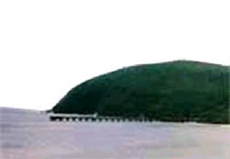

Megasthanes who visited the Court of Chandragupta Maurya (322-297 BCE), mentioned that Andhras had 30 fortified towns and an army of a million infantry, 2000 cavalry and 1000 elephants. Buddhist books reveal that Andhras established their kingdoms in the Godavari Valley at that time. Asoka referred in his 13th rock edict (232 BCE) that Andhra was under his rule.

Ptolemy mentions several important ports on the Andhra Coast between the mouth of the Ganges and the Godavari from where ships sailed to the East. Podouke (Pulicat), Masulipatnam, Melange (Mahabalipuram) and Sopatama were a few of the important ports which exported spices, sandal, pearls, Aghil, Camphor and Silk that was imported from the farther East.

Chinese merchants had their warehouses at the mouth of the river Krishna. After the Satavahanas the Pallavas, who were originally from Andhra continued the seafaring tradition. It appears from a study of the Buddhist stupa found at Prome (Braburma) that Buddhism probably came to that country from Andhra desa. The cultural influence moved on to the Malay peninsula.

TAMIL MERCHANTS IN THE TRADE OF MEDIEVAL ANDHRA

11th to 13th century records of the Andhra ports show Tamil influence in trade.

Visakhapattana is mentioned as a port town of Madhyama Kalinga and Ghantasala.

The second name of the town is mentioned as Kulottunga Chola Pattinam or Chola Pandya Pura

CHOLAS AND THEIR SEA POWER

Chola rulers Raja Raja (985 – 1014), Rajendra (1012 – 1014) controlled the Eastern seas and colonised countries of East

The merchants of Tamilnadu established their trade even in China

They were called Nanadesi-thisaiyayirattu- Ainnuttruvar.

QUANZHOU INSCRIPTION
1281

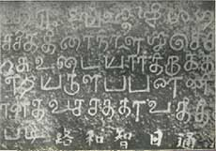

IMPERIAL CHOLAS

Vijayalaya (850-871); Aditya (871-907); Parantaka I (907-955);

Arinjaya (956-967); Parantaka II (956-973);

Raja raja I (985-1014); Rajendra I (1012-1044)

Daughter of Rajendra I Ammanga Devi m Rajaraja Narendra of Eastern Chalukya

Their son Rajendra or Kulottunga Chola I (1070-1120)

SIMACHALM TEMPLE INSCRIPTIONS

An inscription in Simhachalam temple of 1099 two Tamil names figure

Karunakaracharyan

Maduranthaka Brahmarayar

The mention of Solar months are seen here against the Lunar months of Telugus

During this phase in two inscriptions, the name appears as Kulottunga Chola Patnam.

TWO INSCRIPTIONS

First one mentions (1090) gifts by a merchant of Anjuvannam hailing from Malabar. (Anjuvannathu vyapari)

The second one (1200) records the gifts by a member of the Velanjiyar community. (Vallabha Samaya Chakravarthi)

These prove that Visakhapatnam was a town with mercantile activity of an assembly (Nakaram).

TEMPLE INSCRIPTIONS

Kulottunga Chola I of Tamilnadu, made endowments to this temple, as evidenced from inscriptions dating back to the year 1087. The Vengi Chalukyas of Andhra Pradesh renovated the original shrine in the 11th century. Much of the structure as it stands to day is the result of renovation by Narasimha I, of the Eastern Ganga dynasty in 13th cent.

Krishna Deva Raya, the Vijayanagar monarch visited this temple in the year 1516, as seen from inscriptions here. There are as many as 525 inscriptions in this temple.

OTHER TRADING PORTS

The next port Ghantasala was known as Chola Pandyapura. It was a trading emporium in 12th Century.

Mottupalli was the other port. In 1245 an Abhaya Saasana (charter of security) was issued to the merchants by Ganapthi Deva (1190-1252) mainly to promote the foreign trade

It was also known as Desyuyukonda patnam

A 1358 inscription in Tamil and Telugu gives he details of the charter

KAKTIYA RULE

Ganpathi Deva was the greatest of the Kaktiya rulers

He ruled for about sixty years and established an empire when trade flourished.

He was followed by his daughter Rudramba (1262 – 1299) During this time Marco polo visited this place and noted the prosperity.

MUSLIM INVASIONS

Under Ala ud din Khilji, Plundering the South was done by Malik Kafur and later Ulugh Khan

1323 saw large chunk of South under Delhi

Prolaya Nayak freed coastal Andhra

Till about 1509 this area was under Gajapthis.

Later Krishnaraya extended his reign upto Kalinga

Aurangazeb,invaded Golkonda in 1687 and for about a period of 35 years this region was ruled by Mughal Nizams.

COLONIAL POWERS

There were several changes and eventually Europeans emerged on the scene

Masulipatnam boasts of a better maritime history.

Bhimlipatnam, once called “The Bristol of the East” and “Pondichery of Circars” had also enjoyed better maritime trade.

Dutch had established trade in these places and British wanted a foot hold in this area.

ENGLISH TRADERS

The English settlement at Vizagapatam was founded in 1682.

According to historian Dr. Sundaram, “It was indeed a curious circumstance that brought Vizag to the notice of the directors of the Fort St. George at Madras.

“An unauthorised trader, Thomas Bowrey, was making for himself a fortune, at this port with the name of the East India Company.”

THE EAST INDIA COMPANY IN VIZAG

The Company then decided to found a factory and thus ‘hinder and defeat any interloper that shall come there’.

At that time Dutch had already established a factory at Bhimlipatam

Within two years, the English factory progressed competing with the Dutch.

THE ENGLISH ASSUME CONTROL

It obtained freedom of trade in the Kalinga, and was granted a cowle of Vizagapatam for an annual rent of Rs. 4,500/- from the Muslim Chief of the Chicacole

The English had a way of establishing themselves.

Unlike the Portuguese, who came into this country with a sword in one hand and a Cross in the other, The English thought only of Trade.

By 1685, the Company had the right to collect dues in Vizagapatam town also!

ENGLISH EXPANSION I

In 1753 the French tried to assert their authority

After two years the British were invited to drive out the French by the Muslim Chief.

In 1765 the English obtained from the Moghul Emperor a firman, granting five northern districts as gift.

ENGLISH EXPANSION II

After John Andrews assumed charge as Chief-in council, there were trouble with the Rajus. At the battle field in Padmanabham, in 1794, China Vijayaramaraju lost his life and the British got their full control.

As early as in the middle of the 19th century, efforts were made to locate a port in Andhra coast since Cocoanada and Bhimli were found inadequate.

A PORT OF THE CENTRAL PROVINCES

Because of the promontory (Dolphin’s Nose) and the possibilities of the natural protection, in 1877 the first detailed report “Vizag, the port of the central provinces” was brought out.

In spite of several proposals to take up the construction of a harbour nothing tangible happened till Bengal-Nagpur Railway initiated the scheme again in 1914.

BNR TAKES THE INITIATIVE

To quote Railway Gazette of May 28, 1913; ‘The existing outlets of India are inadequate, and much as the treasury may object to the creation of another demand, sooner or later the harbour site at Visakhapatnam must be dealt with.’

The development of Vizag as a port was sanctioned by the Secretary of State in 1925, the necessary funds being provided by the Government of India.

The work of development was entrusted to the Railway Board and with the approval of the Board of Directors; they appointed the Agent of the Bengal Nagpur Railway as their Administrative Officer. The Board of Directors also agreed to the use of their organisation to assist the Administrative Officer

LOCATION OF A PORT

The entire area was nothing but a huge swamp.

The available documents from the archives of Visakhapatnam Port relate to the tale of acquisition of the land in a chronological order through the Government Orders and reads like a fairy tale!

CONCEPT OF A PORT IS BORN

Below is the extract from an appendix to G. O. No. 3512 W., dated 22nd December 1892.

1. In 1861 and 1862, two portions of the swamp at Vizagapatam, aggregating 79 acres in extent, were granted to a Mr. Warfield subject to the payment of an assessment of Rupees 12.

Mr. Warfield sold this land to a native, who resold it to Right Rev. Dr. Tissot, the Roman Catholic Bishop of Vizagapatam.

In 1868, Dr. Tissot, applied for an additional piece of land which, together with that already purchased by him, he wished to convert into a model farm for the orphanage attached to his mission.

This was granted subject to the payment of an assessment of Rs. 22 (G. O. No. 636, dated 11th March, 1868). The extent of the land was not specified, but as it was proposed to assess it, at the same rate as the lands granted to Mr. Warfield, the area has been calculated to be acres 145.

In 1869, Dr. Tisssot applied for a further grant of 1,000 acres of the swamp which he considered absolutely necessary to ensure success in the trial he was making to establish a model farm. This was also granted, subject to an assessment of Rs. 88 and subject also to the condition that 100 acres should be reclaimed every year, one year being allowed for preparations. (G. O. No. 722, dated 17th March 1869).

On a representation from Dr. Tissot, the Government modified its order of March 1869 so far as to allow him to hold the land (1,000 acres) free of assessment during the first ten years, and observed that he should still abide by the condition which bound him to reclaim at least 100 acres of the swamp every year . (G. O. No. 8007, dated 22nd November, 1869.)

In 1871 he applied for reclamation from 10 to 40 years and for remission for the whole period, but the Government passed the following order:

“The free grant for 10 years will be altered for a free grant of 21 years. A certain portion of the swamp (to be fixed by the Collector with the sanction of the board) to be reclaimed triennially, in default the grant to lapse to the Government.” (G. O. No. 1169-A, dated 7th July 1871).

Later on in the same year he applied to the Board to obtain a modification of these terms, but in its Proceedings, No. 4539, dated 30th October, 1871, it declined to take further action, observing “it is not to be supposed that the Government will show any rigour in the enforcement of penalty of resumption if it can be provided that the Bishop has done his best at every triennial inspection undertaken by the Collator”.

In 1874, the Collector and the District Engineer were in opinion that Dr. Tissot had not observed the terms of the grant, as only 13 ½ acres of the land had been brought under cultivation and that his action was prejudicial to certain proposed harbour works, the grant should be canceled. The Advocate - General was consulted as to whether the land might be resumed, and on his advice, he Board was directed to inform Dr. Tissot that the grant has been cancelled.

The Government also had expressed its willingness to consider favourably any fair claims for compensation (G. O. No. 567 dated 8th May, 1874). Dr. Tissot protested on several grounds, one of which was that he undertook only to drain the lands and that he had reclaimed the whole swamp in the sense of rescuing it from the water.

The Advocate-General who was again consulted, advised an amicable settlement. The order of resumption was held in abeyance and Captain Taylor, Master Attendant at Madras, was directed to report on the effect which the reclamation had or likely to have on the harbour. (G. O. No. 1341, dated 17th October, 1874) Captain Taylor’s report was in favour of the reclamation and Dr. Tissot was therefore, permitted by the Government to proceed with his work(G. O. No. 509 dated 2nd April, 1875).

In 1890, the Collector of Vizagapatam, reported that Dr. Tissot’s enterprise had proved a complete or almost a complete failure, and that it was necessary, therefore, to cancel the grant. He observed “a little land along the upper or northern edge of the swamp has been brought under cultivation and a purposeless tank or two has been dug, but this is all that can be reasonably called reclamation”

He accordingly proposed to call upon Dr. Tissot’s successor to prove that the conditions under which the grant was made had been fulfilled.

The Government, however, was of opinion that the word ‘reclamation’ used in the correspondence relating to the grant of 1869 simply meant ‘drainage’ and that the grant could not be cancelled.

The term of 21 years, for which exemption from assessment was conceded, having expired on the 28th December 1890, after allowing for the period of suspension of the work in 1874 and 1875, the collector was directed to inform Dr. Tisssot’s successor that the land (1,000 acres) granted in 1869 was liable to assessment from fasli 1300 (1890-91) and to ascertain whether the mission was willing to retain possession of the land on payment of assessment (G. O. No. 305 dated 13th April 1891)

Rev. J. M. Rossat (Dr. Tissot’s successor) has intimated that the mission wishes to retain possession of the land and paid the assessment forthwith (G. O. No. 4171 dated 23rd July 1891).

From the collector’s report while submitting Rossat’s letter it appeared doubtful whether the swamps were really drained as the Government proposed!

OWNERSHIP OF LAND

The position however was that the Roman Catholic Mission sold 200 acres to East Coast Railway thereby establishing their ownership!

Compensation was fixed by the civil court at Rs 5 and As 4 per acre and A. T. Mackenzie, the executive engineer, Vizagapatam Harbour investigation recommended that the Government could possibly buy all the rest for a mere Rs 5,000/- which would be of use to the port. (23rd December, 1899).

REPORTS AND WORKS

In September 1914, Sir John Wolfe Barry, Lyster & Partners submitted proposals for the improvement and development of the harbour. They took into account all the earlier reports and numerous other schemes dealing with the subject going back as far as 1859

REPORTS AND WORKS

Sir Arthur Cotton who had earlier visited this site considered it to be a fundamental mistake to regard Vizagapatam as first class site and proposed to form an outer harbour by running out a break water from the salient point of Dolphin’s Nose for about 200 yards.

Sir Arthur Cotton considered Cocoanada to be a better place to develop than Vizagapatam.

REPORTS TAKE SHAPE

However, Mr. E. S. Thomas in 1872 submitted proposals for creation of Inner Harbour. He considered Vizagapatam to be the most natural and most easily formed Port in the East Coast of India.

In 1873, Captain Waters, Master Attendant at Vizagapatam, proposed a groyne to run out from the south side of the harbour and an outer harbour.

Later reports also considered it better to have inner harbour and in 1882, Mr. B. Parkes Consulting Engineer to the Madras Harbor considered that Vizagapatam would be a better harbour with deeper water than usual, near shore and the inner harbour to be a practical solution.

A PROPHETIC STATEMENT

Parkes stated “If Vizagapatam ever becomes a place of great trade, the reasons for carrying on the trade will be added step by step, and by the time the great need for sheltering ships are required the conditions of the case will be different from the present”.

He continued that the could only say that 30 times the present trade might be possible in future.

“I can only now say that if in the distant future a harbour outside Dolphin’s Nose is required it can easily be made. If on the other hand an inland dock is preferred with deep water berth, such a scheme would be perfectly practicable”.

PROJECT PLAN

Mr. Thorowgood studied the proposal and then his report showed a rough plan for a large harbour with an easterly entrance, by an extension of the north groyne and the addition of south groyne, estimating the cost at 43,27,272/-. When studied, the report was found to be incorrect as far as the cost was concerned by Mr. G. T. Walch who was the Chief Engineer of the Government of Madras. He estimated the cost as 65 lakhs.

PROJECT PLAN

Subsequently Madras Government decided to depute an officer of the Public Works Department, to take accurate, detailed and systematic observations for a full year and this officer commenced work in 1898. Based mainly on his report the proposals by Sir John Wolfe Barry, Lister & Partners were made which was the real beginning of this harbour. The scheme was adopted taken up and completed in 1933!

THE PORT IS BORN

The inauguration of the port itself was on the 19th December 1933, though on 7th October 1933, first sea going vessel S. S. JALADURGA entered the harbour. This is in contrast to today’s delays in projects!

The actual usage started even before the official inauguration!

THE INAUGURATION

It is a point of interest to note that the Port itself was inaugurated by the then Viceroy George Freeman Freeman-Thomas, L Willingdon... from on board the Dredger S. D. Vizagapatam, the grand old lady having been put to rest after more than 50 glorious years of service!

The ceremony was reported in full front page in The Hindu dated December 20, 1933

PROTECTION OF THE HARBOUR

To protect the harbour W. C. Ash studied Durban Port which has striking similarities with Vizagapatam, and got two ships - JANUS and WELLESDEN and scuttled them south of the entrance channel to form the breakwater which was cheaper than building a wall in the sea!

This prevented the movement of sand to the entrance channel.

COST OF THE HARBOUR

The dredged material for the port was 281.8 million cubic feet of soft material. It had a quay length of 1600 feet for berthing three vessels. The port then possessed a railway track of 12.71 miles. The entire port was constructed at a total cost of 378 lakhs of rupees. In the first year of operation it handled a traffic of 1.3 lakh tons!

ADMINISTRATION OF THE PORT

The port had a chequred history

At different times it was under, War department, Communications Department, Commerce Department and later under the B. N. Railway.

The littoral drift caused problems but beach nourishment was successfully carried out here from the beginning.

SOME PLACE NAMES

The highest mount, named after Mr. Ross, a local authority, built a house on it in 1864. This was later converted into a Roman Catholic Chapel and named "Our Lady of the Sacred Heart".

Thomas’s Folly is a house on the hill which can be seen even today.

Scandal Point is named after some occurrences as noted in the annals of Waltair Club

Dolphin's nose is a huge rock, 357 metre high, shaped like a Dolphin. The rock juts out into the sea, forming a headland on which is the lighthouse. This lighthouse has a beam that can be seen 65 km out at sea.

VIEWS IN EARLY 20th CENTURY 1.
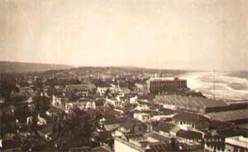

VIEWS IN EARLY 20th CENTURY 2
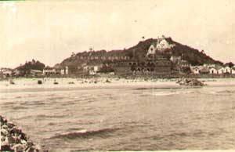

VIEWS IN EARLY 20th CENTURY 3
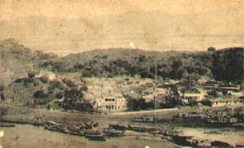

VIEWS IN EARLY 20th CENTURY 4
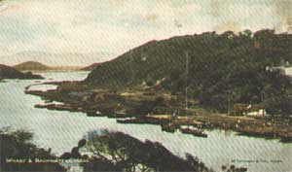

VIEWS IN EARLY 20th CENTURY 5
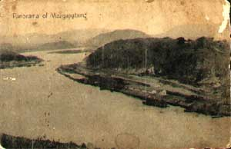

VIEWS IN EARLY 20th CENTURY 6
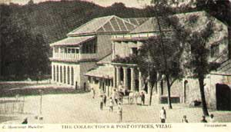

VIEWS IN EARLY 20th CENTURY 7
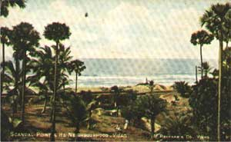

LOOKING THROUGH THE WINDOW OF FUTURE
