Liquefied gases - Safety aspects By Govind V Nori
This paper is in 8 sections. was prepared & presented at the behest of industry in 2002 & updated in 2012.
Introduction
At the beginning we have to define and understand what safety means:
Safety regulations consist of:
- safeguarding life of personnel,
- procedures to avoid accidents, &
- protection of property.
It is stated often enough that 95% of all the accidents occur due to human error.
Apart from all the regulations, safety is dependent upon:
- having knowledge about the product to be handled;
- being fully conversant with both hazard and precaution;
- in obeying the rules – failure to do so can result in death and catastrophically damage the property and the environment;
- dangers anticipated in case of accidents;
- safe working procedures;
- effort & hard work from everyone to achieve high safety standards; &
- common sense & keen observation.
- This paper deals with basic safety while Liquid Anhydrous Ammonia and LPG (Butane & Propane) cargoes are being discharged in Visakhapatnam port. Danger can always be present in a Liquefied Gas Carrier and at the terminal whether loading or discharging and, although the carriage of liquefied gases by sea is historically safe practice, this has been achieved by strict compliance of the rules. Risks can be avoided by taking care and by strictly adhering to the rules laid by IMO and local administration. You are not expected to be fully conversant with all of the rules – but you are expected to take care, avoid risks and follow instructions. To be able to avoid risks you must know what they are. The intention in presenting the paper is to create public awareness of the dangers and risks involved with liquefied gas cargoes in general. Hazard – is the potential to cause harm. Risk – is the chance of harm. Risk Assessment- a structured analysis of risk factors. Risk Mitigation – if risk is deemed unacceptable it should preferably be eliminated, or the means and procedures provided to minimise its effect.
Liquefied gas production:
•Liquefied petroleum gas (LPG) is the general expression for propane, butane and mixtures of the two, which are produced from two distinct sources. Firstly, it is obtained from the crude oil processing in refineries or as a by-product from chemical plants. This LPG is normally only available in pressurised form and may be marketed locally in pressure cylinders or small pressure tanks. Secondly, LPG is produced from natural gas streams or from crude oil at or close to the point of production. Natural gas from wells consists largely of methane, smaller quantities of heavier hydrocarbons which are collectively known as natural gas liquids (NGL), and varying amounts of water, carbon dioxide, nitrogen and other non-hydrocarbon substances. The relationship between natural gas, NGL and LPG is shown in the figure below.

Methane (C₁)

Natural Gas

Water, carbon dioxide, nitrogen and other

non-hydrocarbon contaminants

Ethane(C₂)

NGL

Pentane(C₅) and
Heavier factions

Propane(C₃)

LPG
Butane(C₄)

Given below is a typical flow diagram for a large natural gas liquefaction plant. If the raw feed gas contains condensates (pentanes and higher hydrocarbons) these will first be removed followed by acid gases (CO₂ and H₂S). The acid gas removal process will have saturated the gas stream with water vapour which is then removed by the dehydration unit. The gas then passes to the fractionating unit where the NGLs are removed and fractionated usually into their substantially propane and butane components. The gas, now very predominantly methane, must be liquefied to produce the main product, liquefied natural gas (LNG).
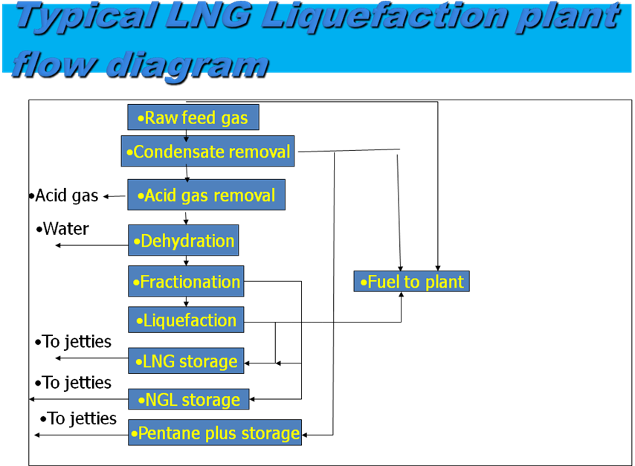
A flow diagram which illustrates the production of propane and butane from oil and gas reservoirs is given below. In this example the methane and ethane abstracted are used by the terminal power station, where as propane and butane, after gas fractionation and chill down are passed on to storage tanks prior to cargo transfer over jetty.
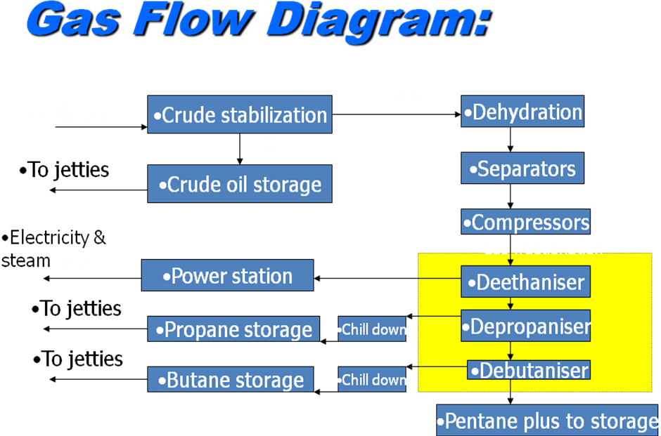
A simple flow chart showing production of ammonia & other chemical gases is given below. Vinyl chloride monomer, ethylene & ammonia can be produced indirectly from .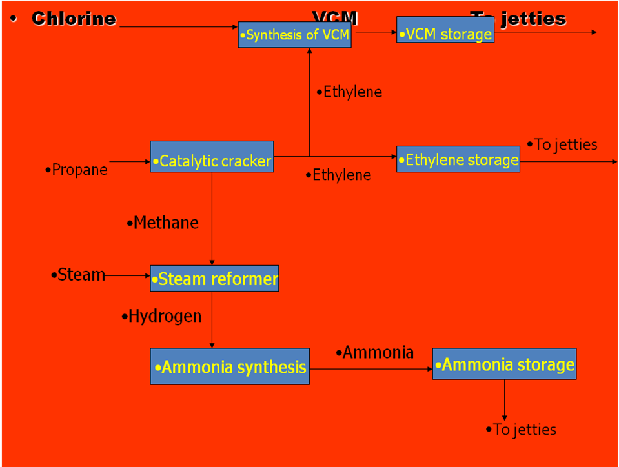

propane. The propane is first catalytically cracked to methane and ethylene which can be synthesised to vinyl chloride monomer with chlorine. The methane from catayltic cracker is first steam reformed to hydrogen and then treated with nitrogen to produce ammonia. The important production inter-relationships between chlorine, propane, vinyl chlorine monomer, ethylene and ammonia can be clearly seen.
Properties:
 | Ammonia | Butane | Propane | LNG
Formula | NH₃ | C₄H₁₀ | C₃H₈ | Hydrocarbon mixture
Family | Alkali gas | Hydrocarbon | Hydrocarbon | Hydrocarbon
Appearance liquid | colourless | Colourless | colourless | A
Appearance vapour | Dense white | Foggy in concentration | Foggy in concentration | A
Odour | Pungent/ suffocating | Virtually odourless | Odourless | A
Main hazard | Toxic | Flammable | Flammable | Flammable
BP@ATP | -33.4⁰C | -0.5⁰C | -42.8⁰C | A
Flash point | -57⁰C | -35⁰C | -105⁰C | A
Flammable limits | 16-25% | 1.5-9.0% | 2.1-9.5% | A
Auto-ignition | 615⁰C | 430⁰C | 468⁰C | A
TLV | 25ppm | 600ppm | 1000ppm | A
Odour threshold | 20-50ppm* | 5000ppm | Odourless**** | A
Reaction-air | No dangerous reaction | No reaction | No reaction | No reaction
Water | Highly soluble** | No dangerous reaction*** | No dangerous reaction*** | No dangerous reaction****
*2000ppm- fatal in 30 mins, 6000ppm- fatal in mins, 10000ppm fatal & intolerable to unprotected skin.
** dissolves rapidly & exothermically to produce ammonium hydroxide.
***may form solid hydrates, insoluble.
****may be stenched to assist detection
‘A’ depends on the composition; shipper’s advice will have full cargo information.
Threshold Limit Value: Maximum concentration of gas, to which it is believed that nearly all persons involved in working with the gas, may be repeatedly exposed, day after day, without adverse effect assuming 8 hours per day, 40 hours per week exposure.

Carriage of liquefied gases by sea:
Hazardous gases are always liquefied for sea transportation – for the simple reason that more can be fitted in a similar volume. Typically, but dependent on the product, 1 volume of LPG is equivalent to 250 volumes of vapour and 1 volume of LNG is equivalent to 600 volumes of vapour. For example, liquid from a disposable lighter would vaporise to fill a 5 litre bucket & mixed with air will form a flammable mixture 3cm deep in a cabin. A whisky bottle full of LPG would vaporise to to 250 litre & mixed with air will form a flammable mixture would fill half a cabin.
The process of liquefaction may be achieved in one of the three ways:
- Reducing the temperature by refrigeration at atmospheric pressure.
- Increasing the pressure at ambient temperature
- A combination of pressure increase and temperature decrease.

This is a cross section of a tank of a Moss type LNG Carrier with spherical tanks. LNG is carried at temperature lower than –160⁰C and most of these carriers are fitted with either the distinctive ‘spherical’ type cargo tanks or membrane tanks. These tanks are heavily insulated to minimise boil off. At present , reliquefaction units are not normally fitted and the boil off gas is burnt as fuel gas to propel the ship. The majority of these ships are between 30000Mt and 80000MT range.


This is a cross section of a tank of a Membrane type LNG Carrier.

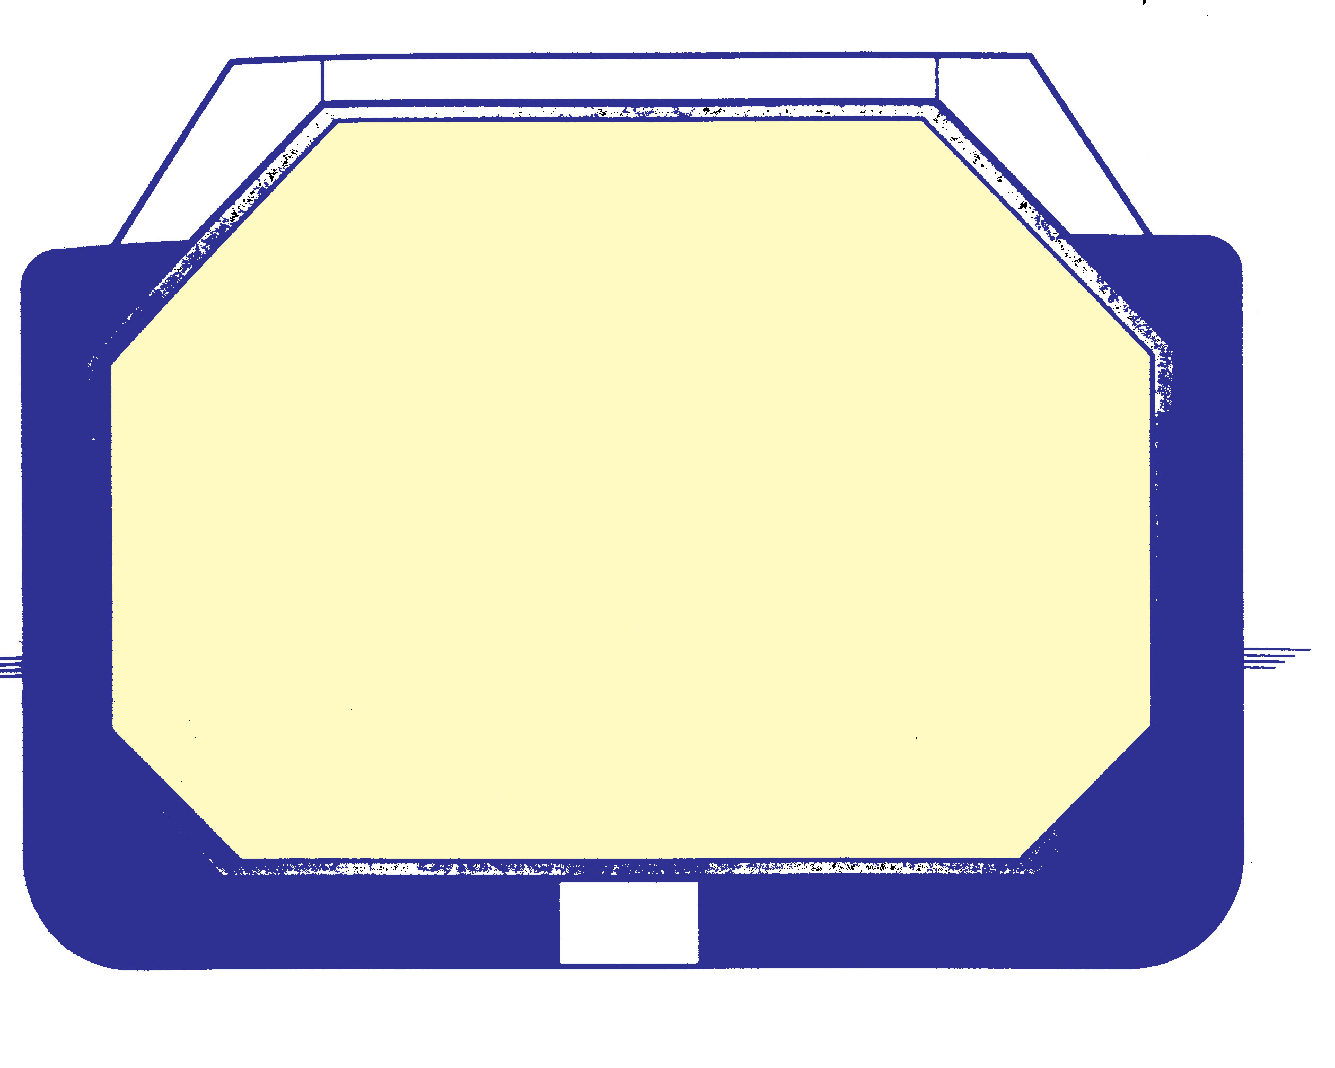
This is a cross section of a tank of a Fully pressurised type LPG Carrier with spherical tanks with a capacity to carry about 5000MT of LPG and carry LPG at ambient temperatures in cylindrical or spherical steel pressure tanks designed to withstand pressures up to 20 bar. They are not fitted with reliquefaction plant and represent a simple cost effective means of transporting LPG and chemical gases to the smaller gas terminals.

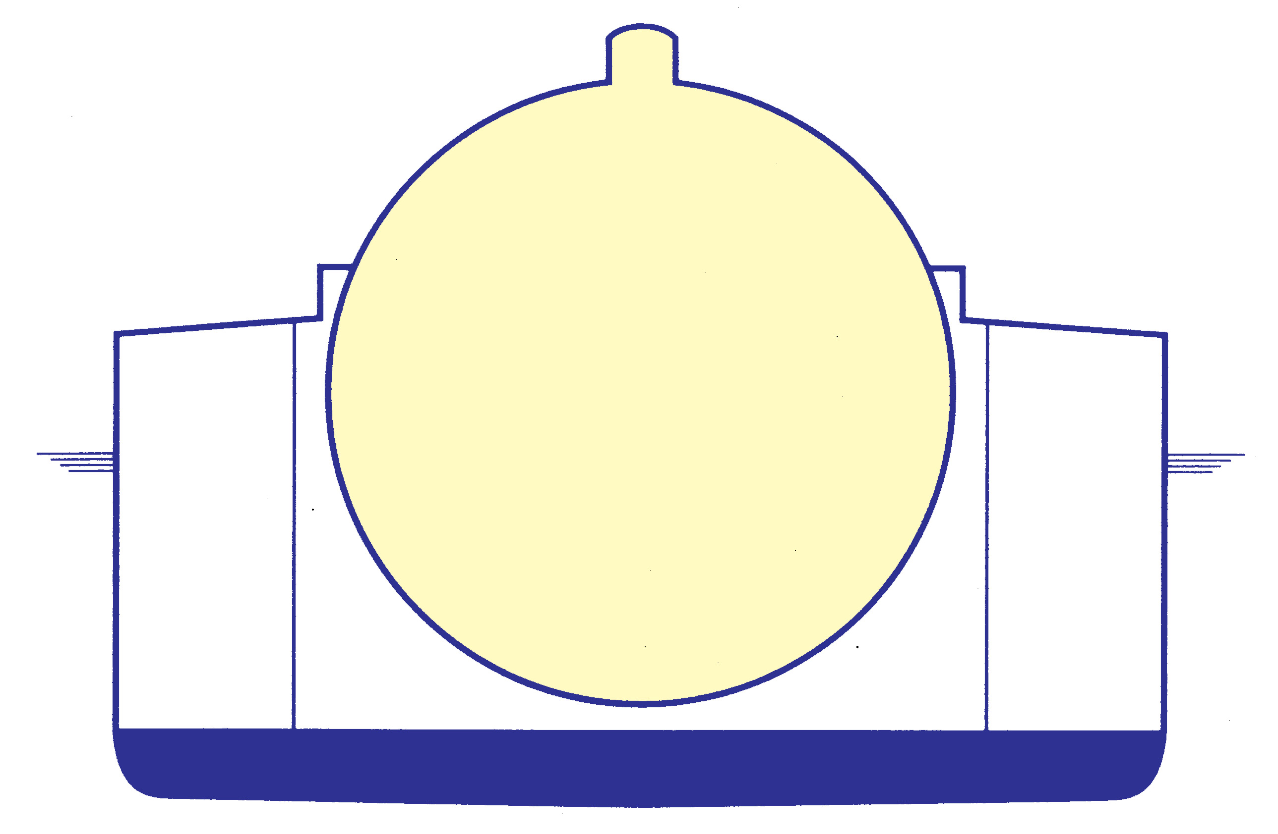

This is a cross section of a tank of a fully refrigerated type LPG Carrier. These ships carry product at near atmospheric pressure at temperatures, dependant upon the type of cargo, between -5⁰C and -55⁰C. The prismatic or box shaped, tanks are made from low temperature alloy steel and are heavily insulated. A secondary barrier is fitted to protect against leakage from the main tank. Hold spaces are inerted when carrying LPG to prevent flammable atmosphere being created in the event of a leak. Powerful reliquefaction units are installed on these ships which generally range from 10,000MT to 55,000MT.
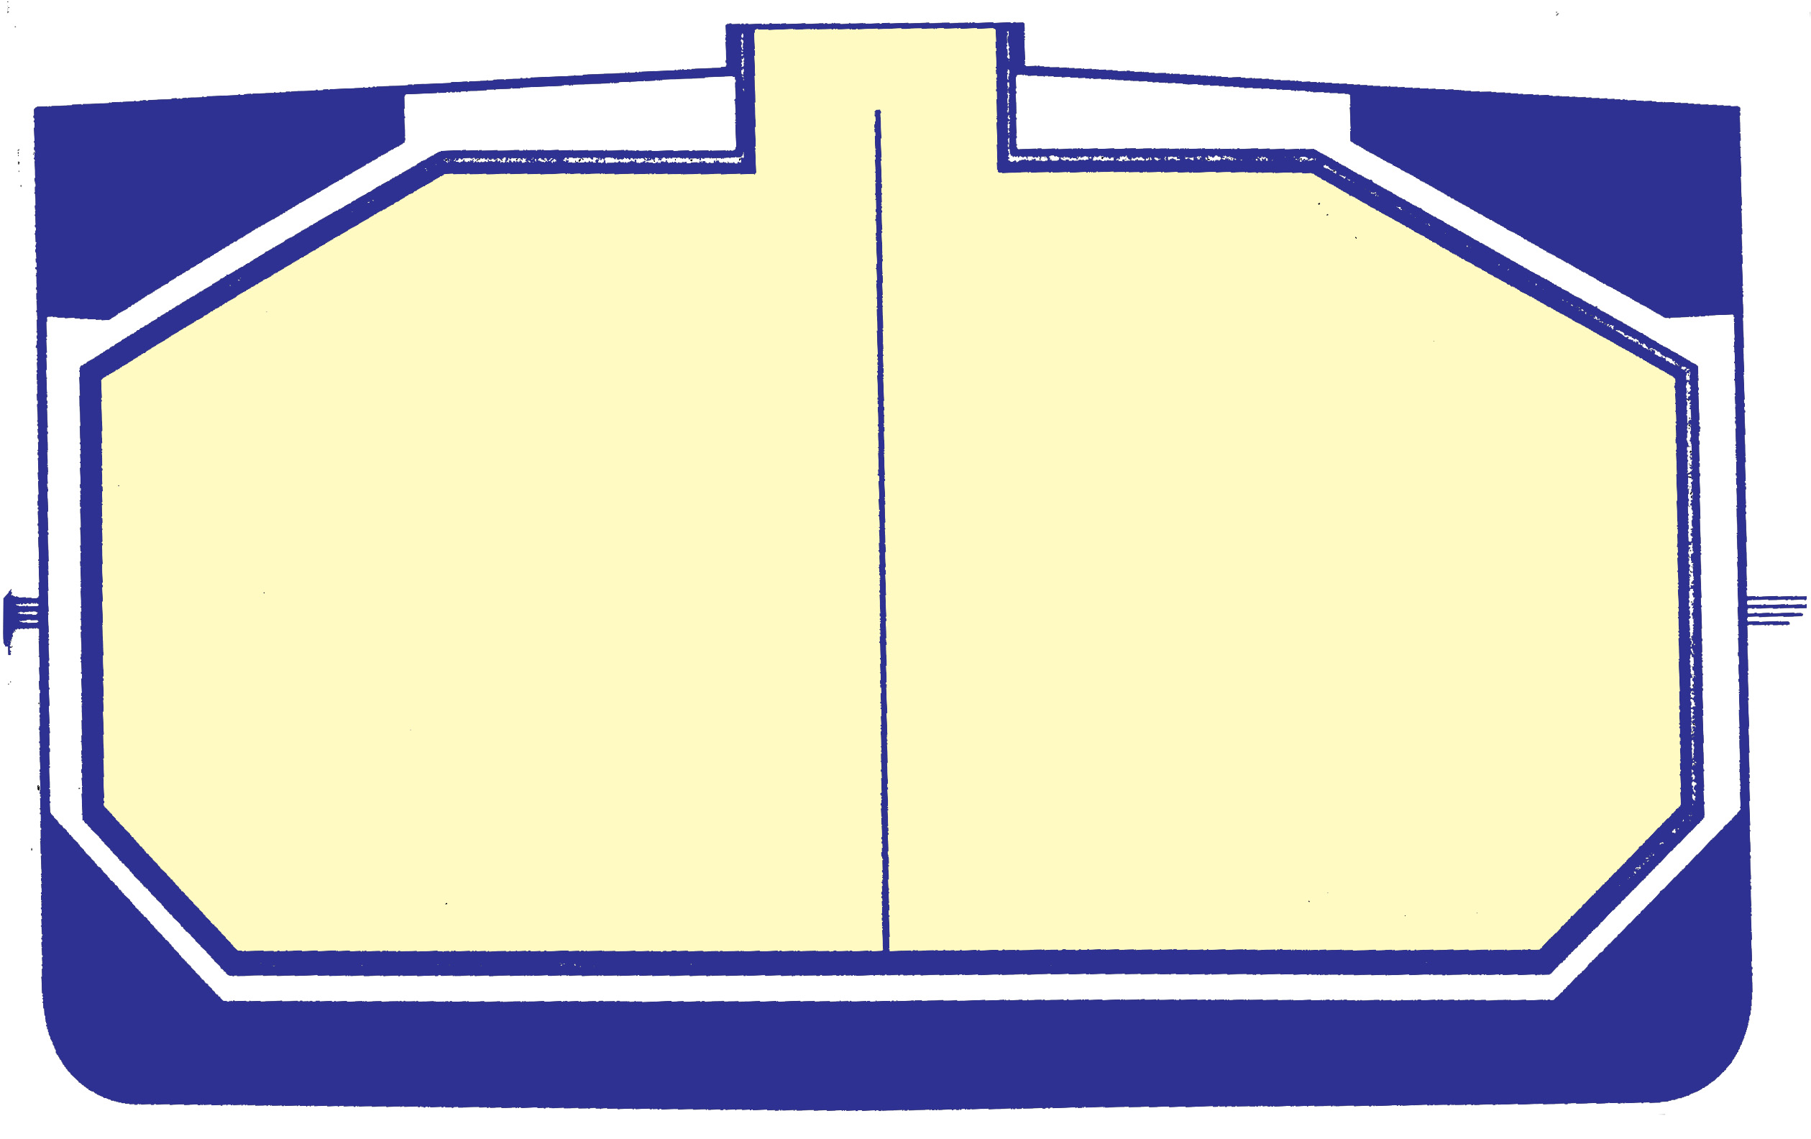
Semi-pressurised carriers are capable of carrying LPG, Ammonia and the chemical gases. These ships have a wide variety of capacities varying from a 2000Mt to 18000MT. They are generally fitted with cylindrical or bi-lobe pressure-vessel type cargo tanks, which are suitable for low temperatures. The tanks may be specially shaped to fit the holds and maximise cargo carrying capacity. By constructing the tanks from special alloy steels the cargo may be carried at temperatures as low as -50⁰C and at pressures from atmospheric to about 10 bar. The cargo tanks are insulated and reliquefaction plant is fitted for temperature control. These ships are able to load and discharge products at both pressurised and refrigerated storage facilities.
This is a cross section of a tank of a Semi-pressurised type Ethylene Carrier. Ethylene ships are a sophisticated type of semi-pressurised ship, designed to carry most liquefied gas cargoes except LNG. They feature cylindrical or bi-lobe, insulated, stainless steel or low temperature nickel-steel cargo tanks able to carry cargoes at minimum temperature of -104⁰C and tank pressures of up to about 6 bar. These ships can load and discharge at virtually all pressurised and refrigerated terminals, making them most versatile LPG carriers in terms of cargo handling ability. Powerful reliquefaction units are installed.
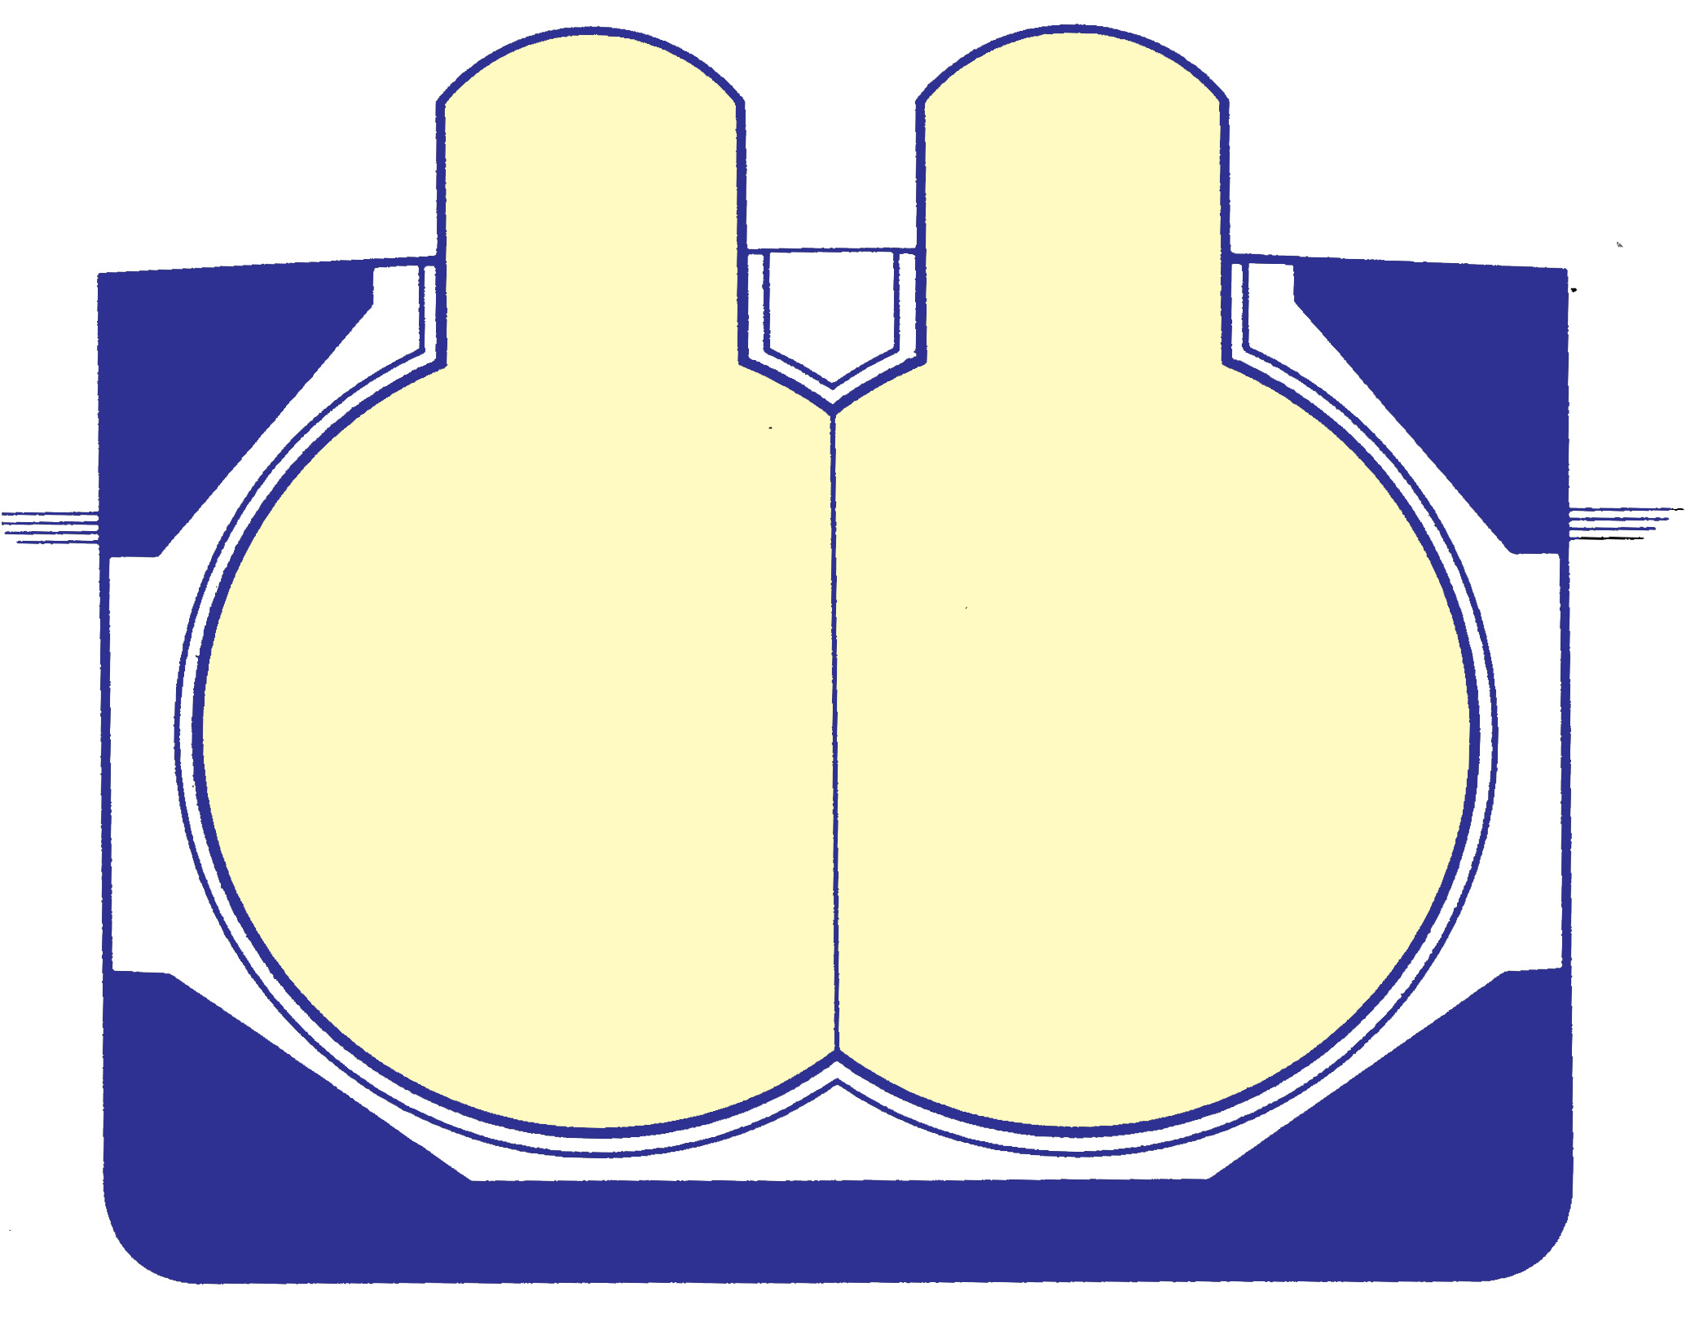

CATEGORICATOGRIES OF GAS CARRIERS
Categories of LPG Carriers
LPG Carriers are divided into seven size categories
CATEGORY | CARGO CAPACITY
CATEGORY | FROM | TO
A1 | << | 6000M³
A2 | 6001M³ | 15000M³
A3 | 15001M³ | 25000M³
A4 | 25001M³ | 50000M³
B1 | 50001M³ | 70000M³
B2 | 70001M³ | 85000M³
B3 | 85001M³ | >>
Categories of LNG Carriers
LNG Carriers are divided into three size categories
CATEGORY |  |  | CARGO CAPACITY
 |  |  | FROM |  | TO
A |  |  | << |  | 60000M³
B |  |  | 60001M³ |  | 200000M³
C |  |  | 200001M³ |  | >>
 |  | ELEVATION OF MANIFOLD |  | RELATIVE TO SEA LEVEL
 |  | NOT GREATER THAN AT MIN OPERATING DRAUGHT IN M |  | NOT LESS THAN AT MAX OPERATING DRAUGHT IN M
 | A1 | 10 |  | 2
 | A2 | 10 |  | 2
 | A4 | 12 |  | 4
LPG | A4 | 16 |  | 6
 | B1 | 16 |  | 6
 | B2 | 18 |  | 8
 | B3 | 18 |  | 8
 | A | 16 |  | 6
LNG | B | 24 |  | 14
 | C | 24 |  | 14

 |  | DIA METER | ININCHES | HORIZONTAL DIST | IN METERS
 |  | LIQUID | VAPOUR | HORIZONTAL MIN | HORIZONTAL MAX
 | A1 | 6 | 4 | 1.25 | 1.75
 | A2 | 8 | 6 | 1.25 | 1.75
LPG | A3 | 10 | 8 | 1.50 | 2.0
 | A4 | 12 | 8 | 2.0 | 2.5
 | B1,B2 | 14 | 10 | 2.25 | 2.75
 | B3 | 16 | 12 | 2.25 | 2.75
 | A | 12 | 8/12 | 2.5 | 3.0
LNG | B | 16 | 12/16 | 3.0 | 3.5
 | C | 16/20 | 12/16 | 3.5 | 4.0
Conventional construction of manifold position: the manifold should be as near as possible to the middle of ship’s length not more than 5 metres for LNG ships or 4 metres for LPG ships & if the arrangement of cargo tanks do not permit the above requirements to be met, the distance of longitudinal centre of the cargo manifold should be placed as near as possible to the mid-ship point(specially for spherical tank construction of ships). An excessive distance from manifold to mid-ships could lend to operational difficulties or incompatibility at some berths. General configuration of cargo manifolds is to have liquid line, vapour line & liquid line(LVL) or liquid line, vapour line, vapour line & liquid line(LVVL). In Japanese ports the arrangement is VLLV, for category A1 LVL will give more flexibility.

Eddies:
Air flowing rapidly past a ship’s superstructure swirls round it – especially on the lee side. Some of the moving air is drawn into swirling currents, which are known as eddies. During cargo operations flammable or toxic gases can eddy and some times these can cause pockets of gas to be present in the most unexpected places. Where they form depends in the wind speed and direction; a wind blowing from forward may cause the gases to accumulate aft of superstucture.

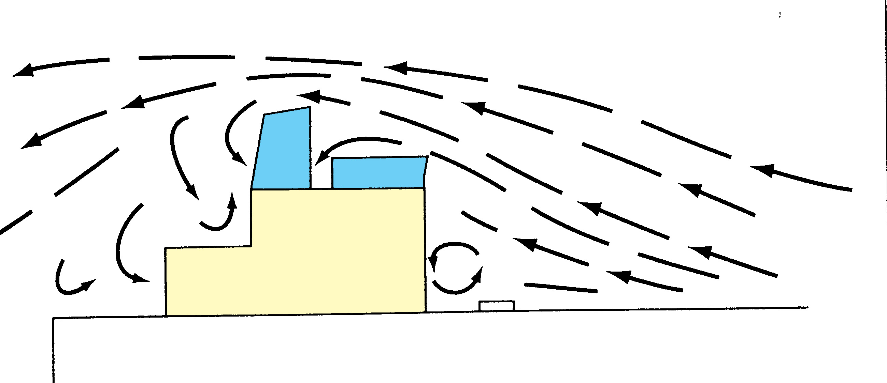

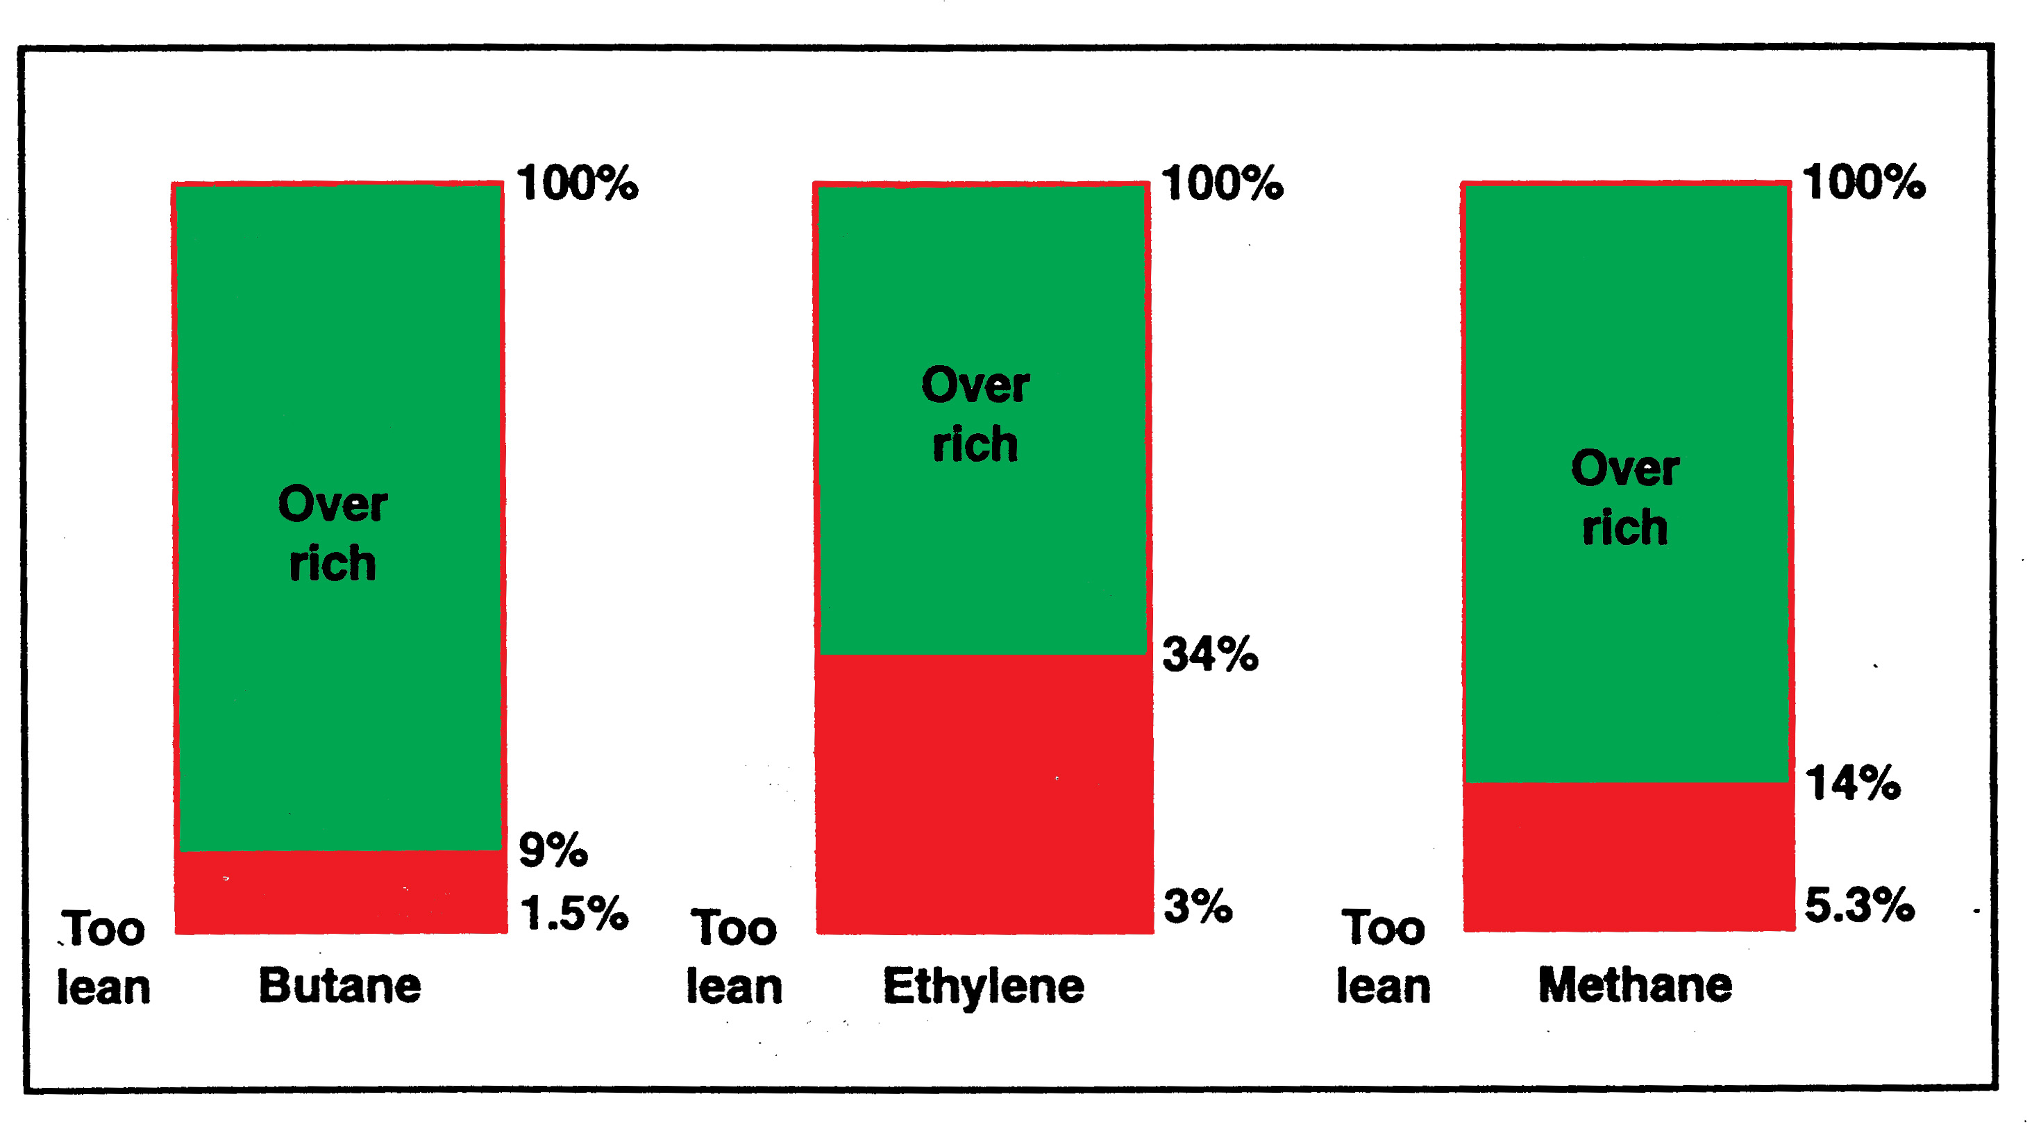

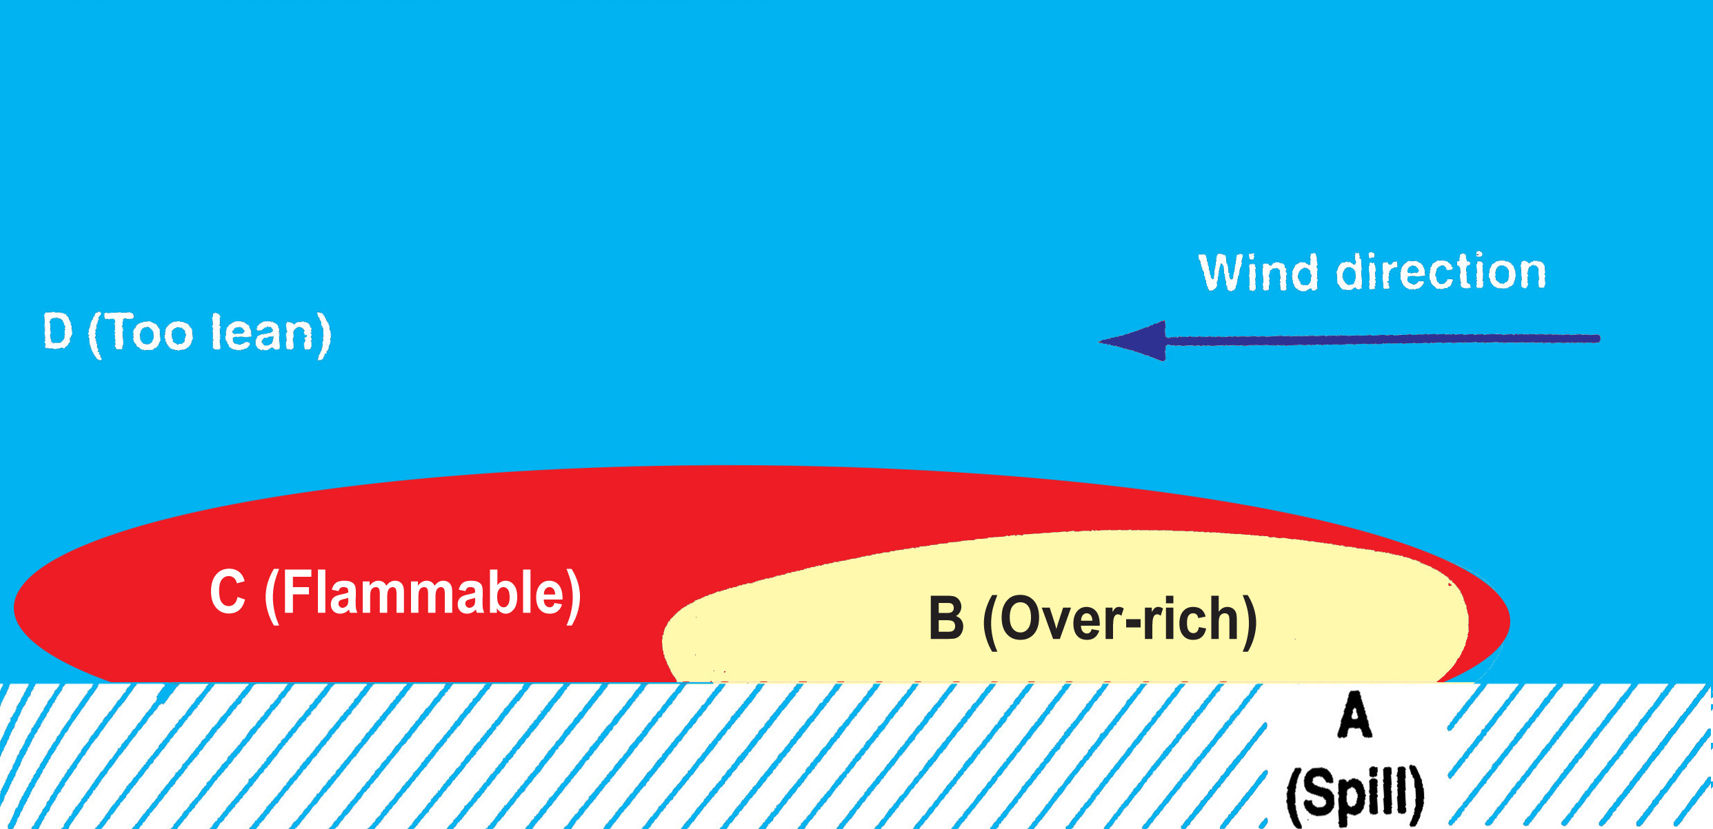

Safe jetty design
•The ship shore interface is a vital area for consideration in the safety of the liquefied gas trade. Considering jetty design (and the equipment which may be needed), safety in this area requires a good understanding of ship parameters before construction begins. In this context the following points are often addressed by the terminal designers:-
    - The berth’s safe position regarding other marine traffic.
    - The berth’s safe position in relation to adjacent industry.
    - Elimination of nearby ignition sources.
    - Safety distances between adjacent ships
    - The range of acceptable ship sizes.
    - Ship’s parallel body length – for breasting dolphin positioning.
    - Properly positioned shore mooring points of suitable strength.
    - Tension monitoring equipment for mooring line loads.
    - Suitable water depth at the jetty.
    - The use of hard arm and their safe operating envelops.
    - Nitrogen supply to the jetty.
    - Emergency shut-down systems – including inter-linked ship/shore control.
    - A powered emergency release coupling on the hard arm.
    - Systems for gas leak detection.
    - A safe position for a ship to shore gangway.
    - Design to limit surge pressures in cargo pipelines.
    - Verbal communication systems
    - The development to Jetty information and regulations.
    - Jetty life saving and fire-fighting equipment.
    - Systems for the warning of onset of bad weather.
    - The development of Emergency Procedures.
    - Vapour return facilities.
- . But unfortunately in our country jetties are built by Civil Engineers (both port & contractors) without consulting the end users. This usually leads to jetty not confirming to standards of most ports & ships.

•Visitors who could either knowingly or unknowingly introduce a source of ignition, therefore, control of the access to the gas carrier is vital. Persons who have no legitimate business on board, or who do not have master’s permission, should be refused access to the tanker. The terminal, in agreement with the master, should restrict access to the jetty or berth.

•Lighting during darkness, the means of access to the tanker to be well lit & adequate lighting should be arranged to cover the area of the ship to shore cargo connection and any hose handling equipment so that the need for any adjustment can be seen in good time and any leakage or spillage of cargo detected.

•Ship to shore bonding cable: A ship/shore bonding cable is not effective as a safety device and may even be dangerous. A ship/shore bonding cable should not therefore be used. Due to local regulations if the ship/shore bonding cable is to be used then the bonding cable is to be visually inspected that the cable is electrically and mechanically sound and a switch of type suitable for use in Zone 1 hazardous area should be provided on the jetty well away from shore manifold area. The switch is to be switched off and then only the bonding cable is to be connected to the ship well away from the ship’s manifold area. The connection of the bonding cable should be carried out before connection of the hose/hard-arm and similarly the disconnection has to be carried out after disconnection of the hose/hard-arm and the switch should be in off position. It is much safer to use an insulated flange.

•Terminals should issue appropriate instructions to the operators of authorised craft on the use of engines and other apparatus & equipment so as to avoid sources of ignition when going alongside a tanker or jetty. These will include advice on spark arresters and proper fenders. Crafts should not normally be permitted alongside during cargo transfer.

•While discharging liquefied gas cargoes, critical periods are when commencing discharging and stopping discharge, as the systems may be subjected to pressure surges. The potential hazards of pressure surges (shock pressures or liquid hammer) resulting from rapid operation of valves should be emphasized to all personnel engaged in cargo operations. Pressure surges can be created when the flow in a liquid line is stopped too quickly. Pressure surges are most likely to occur during cargo transfer as a result of the following occurrences:
- Closure of quick closing shut off valve
- Rapid closing of or opening of manually or power operated valve
- Slamming shut of non-return valve
- Starting or stopping of a pump.
The hazard is greatest when the cargo is being transferred over a long distance and at high velocity. If the valve is shut too quickly under these conditions the deceleration of the large column of liquid in the line sets up shock waves which can travel down the line causing extremely high surge pressures. The cargo hose/hard arm is most vulnerable to failure in these circumstances.
In 1987 the risk analysis of LPG discharge at Visakhapatnam port carried out by LRS for HPCL, issued a recommendation to stop discharge operations while a ship is passing the LGC either to berth or to sail. In 1992, the author brought the abovementioned problem to the notice of the LRS surveyor, who has specially come to carry out the risk analysis for 12500MT discharge at Visakhapatnam Port. It was verbally agreed that the above recommendation be deleted. However, this was not done in the ensuing report. It is very important to make correct rules. It is equally important that the rules are not broken, but amended if deemed necessary. If the rule is found to be redundant, or needs to be amended for any reason whatsoever, then it is imperative that the rule be changed with the consent of the all the parties concerned. An example: Some ships due to their size or type of cargo they carry are categorized as daylight movement in many ports. When a law/rule is made, the parameters must be absolutely clear leaving no grey areas in definitions. Here, it is very important that the correct meaning of law/rule be specified so that there is no doubt whatsoever what the law means and there will be no scope to interpret the meaning of law differently to suit commercial requirement. E.g When a vessel is termed as a daylight movement the meaning of the term “daylight movement” should be well defined and not left to the interpretation of individuals. Logic states that if the vessel is berthing, in the evening, then the vessel should have passed at least two ropes to jetty in daylight, or enter the breakwater at morning daylight & if the vessel is leaving the jetty in the morning then vessel should be singled up by daylight & if the vessel is sailing in the evening then the vessel should be in the outer turning basin in daylight. Here, it is very important that the correct meaning of daylight movement be specified so that there is no doubt whatsoever what the term daylight movement means and there will be no scope to interpret the meaning of daylight movement differently to suit commercial requirement.
• The procedures at the wharf & at the plant for commencement of discharge, during discharge & on completion of discharge operations should be written and displayed so that a new person posted is well aware of the correct procedure.
• Bunkering: In most American, Australian, Canadian, European, British Japanese, Singapore & Korean ports(in Visakhapatnam till the year 2001 & 2005) bunkering activity is not carried out when the LPG MUA/Hose is connected. Barges coming alongside are prohibited for safety reasons. While bunkering scuppers should be properly plugged, but this is in contrast to the code for liquefied gas carrier norm which states that the scuppers should be left open, because, if scuppers are plugged, then the spillage of liquefied gas accumulates on the deck, consequently the deck plating will become brittle and subject to failure of the deck plating. In general, on gas carriers, bunkering operations by barge will not take place during cargo operations as this is usually disallowed by terminal regulations. This avoids a bunker craft with possible ignition sources being allowed alongside a gas carrier. In case of cargo leakage open scuppers on gas carriers are an important feature to allow cold liquids to escape quickly so reducing the risk of metal embrittlement and the possibility of small pool-fires on a ship’s deck. This problem needs to be addressed as ship’s safety & port’s oil pollution are involved. The latest rule being the drip trays under the manifold not to be filled with water but a hose withstanding the low temperature to be connected to drip tray and other end to be below waterline during loading & discharging operations.

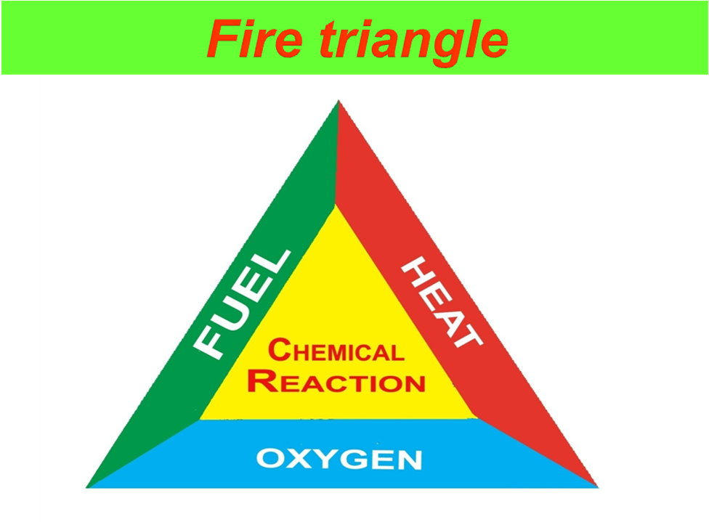
Fire is a chemical reaction, which occurs when fuel and oxygen are brought together with sufficient heat to cause ignition. This is represented by the fire triangle. A fire cannot start or continue if one side of the fire triangle is absent. Taking correct initial action in the early stages of fire, whilst it is small, will maximize the chances of extinguishing it. Remember, even the biggest fires start as a single flame. Large fires will probably be small, but grow quickly because they are not tackled correctly, in early stages.

Sources of ignition: Match boxes, Lighters, Studded shoes, Shavers, radios, Electric cooking appliances, Chipping on deck, Tools(dropping of),Torches, Walkie-Talkies which are not intrinsically safe, Mobile phones ( cell phones are known to be capable of igniting flammable vapours. If dropped they may break open, exposing the battery and electrical circuit.), Sparks arising from crafts, Hot exhaust pipes of vehicles etc.

The gases produced by combustion are heated by reaction. In open spaces, gas expansion is unrestricted and combustion may proceed without undue over-pressures developing. If the expansion of the hot gases is restricted in any way, pressures will rise and the speed of the flame travel increase. This depends on the degree of the confinement encountered. Increased flame speed gives rise to more rapid increase in pressure with the result that damaging over-pressures may be produced. Even in the open, if the confinement resulting from the surrounding pipe-work, plant and buildings is sufficient, the combustion can take on the nature of explosion. In severely confined conditions, such as within a building or a ship’s tank, where the expanding gases cannot escape, the internal pressure and its rate of increase may be sufficient to burst the containment. Here, the explosion is not due to high combustion rates and flame speed: it results more from the surge of high pressure upon containment rupture.

:Flammable cargo hazards:
    - All liquefied gas can evaporate and form vapour.
    - In most cases these vapours given off by the liquid burn.
    - The liquid cannot burn by itself.
    - The liquids, which do evaporate at low temperatures, are the most dangerous.
    - For fire you require oxygen (from atmosphere), vapours and a source of ignition.
    - The vapours will burn only if they are between LEL (lower explosive limit) and UEL (Upper explosive limit).
    - Flameless explosion: An explosion like-event as ‘flameless explosion’ or ‘rapid phase transition’ (RPT) may occur if very cold liquefied gas strikes water. This is not considered a major hazard as the energy release is limited and there is no evidence that fire would result. The possibility of large quantity of gas reaching the critical condition is remote.
    - Pool fire: This takes place with pool of liquid at the leak source and the pool getting ignited.
    - Jet fire: When the leak catches fire.
    - Flash fire: This happens when there is a leak and does not ignite immediately but after the vapours travel some distance downwind and getting ignited and is dangerous.
    - VCE: Vapour cloud explosion happens some time after leakage of liquid and vapour cloud has formed is very dangerous.
    - BLEVE: Boiling liquid/expanding vapour explosion is the most dangerous. BLEVE, is an explosion resulting from the catastrophic failure of a vessel containing a liquid significantly above its boiling point at normal atmospheric pressure. The container may fail for any of the following reasons: mechanical damage, corrosion, excessive internal pressure, flame impingement or metallurgical failure. The most common cause of a BLEVE is probably when fire increases the internal tank pressure of the vessel’s contents and the flame impingement reduces its mechanical strength; particularly at that part of the vessel not cooled by the internal liquid. As a result, the tank suddenly splits and the pieces of the vessel’s shell can be thrown a considerable distance with concave sections, such as end caps, being propelled like rockets if they contain liquid. Upon rupture, the sudden decompression produces a blast and the pressure immediately drops. At this time the liquid temperature is well above its atmospheric boiling point and, accordingly, it spontaneously boils off, creating large quantities of vapour which are thrown upwards along with liquid droplets. Where the gas/air mixture is within its flammable limits, it will ignite from the rending metal or the surrounding fire to create a fire ball reaching gigantic proportions and the sudden release of gas provides further fuel for the rising fireball. The rapidly expanding vapour produces a further blast and intense heat radiation. Such BLEVE incidents have occurred with rail tank cars, road vehicles and in a number of terminal incidents. There have been no instances of this kind on liquefied gas carriers. Under the Gas Code, pressure relief valves are sized to cope with the surrounding fire and, as for shore tanks, this helps to limit the risk. It must be said that the chance of a fire occurring in the enclosed space beneath the pressurized ship’s tank is much smaller than on an equivalent tank situated on shore. This minimizes the possibility of a surrounding fire occurring on a ship and almost excludes the possibility of a BLEVE on a gas carrier.

In case of LPG/AMMONIA leaks:
⇨Stop cargo operation & shut the valves on cargo line.
- No mechanised floating craft to come in the vicinity of the vessel & no vehicles are permitted to be near scene as a potential fire hazard.
⇨ All superfluous persons to clear the area as fast as possible.
- Do not use cell phones & VHF sets which are not intrinsically safe.
- Do not use torch lights which are not approved for use on gas carriers.
⇨ Do not panic.
Leak on a ship:
⇨ Enquire and inform necessary authorities as prescribed by VPT and the receivers.
⇨ Let the Ship’s crew handle the situation and do not interfere.
⇨ Ship board personnel are trained personnel and they know the drill.
⇨ They will give the necessary alarms if the situation demands it.
⇨ From shore the sprinklers on jetty to be turned on.
Leak on Jetty:
⇨Use spray nozzles near the leak to enable personnel to rectify the leak.
⇨If required, assist in disconnecting the hoses to enable to the vessel to be cleared from the jetty.
In case of fire on board ship: Action by ship:
As a general guide, when liquefied gas fire occurs, the correct procedure to adopt as follows:-
Raise alarm (a continuous group of three long blasts)/ (.......--------) on ship’s whistle
        - Cease all cargo operations & then close all the valves.
        - Contact terminal
        - Assess the fire’s source and extent, and if personnel are at risk
        - Implement the emergency plan
        - Stop the spread of fire by isolating the source of fire
        - Cool surface under radiation or flame impingement with water
        - Extinguish the fire with appropriate equipment or, if this is not
possible or desirable, control the spread of fire.
          - Standby for disconnecting the hoses/hard-arm
          - Prepare engines and crew to cast off.
Action by terminal:
        - Inform necessary authorities as prescribed by VPT & receivers.
        - Close all the valves.
        - Turn the sprinklers on
        - Give any assistance to the ship as required by them
        - Stand-by to disconnect the hoses/ hard-arm
        - Stand-by to assist in fire fighting
        - Inform all the ships
        - Implement terminal/port emergency plan.

Fire on another ship or ashore: Action by ship:
- Cease all cargo operations and then close all the valves
- Disconnect hoses/hard-arm
- Bring engines and crew to stand-by, ready to cast off.
Action by terminal:
- Raise the alarm.
- Contact the ship.
- Cease all cargo operations and then close all the valves.
- Fight fire and prevent fire from spreading.
- If required, stand-by to disconnect hoses/hard-arm
- Inform all the ships.
- Implement terminal/port emergency plan.

Fire protection:
Appropriate terminal fire protection includes not only an adequate fire fighting system, but appropriate prevention measures as well. At terminals handling liquefied gas products, a permanently fixed gas detection system should be installed. The standard response to an oil terminal fire is to stop flow of fuel, and to maintain cooling water on the terminal structures until the fire burns out. In some cases, particularly for small fires, the fire can be extinguished before all the available fuel is burned. It is critical to this philosophy that an adequate isolation system is in place to quickly close off all sources of fuel (terminal pipelines, tanks, etc.,) and that an adequate number of monitors strategically placed about the terminal are available to put cooling water in the fire area. Fire water must be carefully thought out to ensure there is an adequate supply, including back-up, in the event of a problem with the main source. Special care must be taken when fighting a liquefied gas fire as extinguishing the flame with foam or water before the source of the liquefied gas is isolated can lead to formation of vapour cloud with the potential for a significant explosion. The practical use of water sprays in diverting a gas release or gas fire and the surface cooling should be thoroughly understood.

Emergency preparedness:
Contingency plans for emergencies arising from all eventualities together with reports on past full scale exercises should be readily available. Emergencies covered by contingency plans should include fire or explosion on the vessel or berth, serious physical damage to shore and terminal facilities, ammonia gas releases, and problems associated with cyclones, earthquakes, etc., as appropriate to the area. It is essential that terminal personnel be prepared for these emergencies. Plans should have been well rehearsed, not only by terminal but also by supporting organisations, in order to ensure the necessary prompt co-ordinated response and mobilisation of emergency equipment. Co-ordinated ship/shore exercises should also be arranged from time to time.
Fundamental emergency procedures are, about how to report and how the alarm should be given to all concerned. These procedures should be developed independently for the terminal, the ship and the ship/shore system. Procedures should warn that a seemingly minor incident may quickly escalate to one of a more serious nature. Much is gained by immediately reporting any abnormal occurrence, thereby permitting early consideration of whether a general alarm is desirable.
Probable scenarios as per LRS risk analysis
Release | LPG | Duration in seconds | Pool fire | Jet fire | Flash fire | VCE
Hose rupture | LPG | 120 | b | b | b | b
Pipeline rupture during unloading | LPG | Till all the liquid is released | b | b | b | b
Pipeline rupture after unloading | LPG | Till all the liquid is released | b | b | b | b
Leakage from sphere’s drain | LPG | 120 | b | b | b | b
Rupture of 16” outlet from sphere | LPG | 120 | b | b | b | b
Catastrophic failure of sphere | LPG | Till all the liquid is released | b | b | b | b
Leakage from ship’s tank | LPG |  | b |  | b | b

Heat radiation effect:
37.5kW/M2 | 100% lethal | Sufficient to cause damage to equipment
25kW/M2 | 3rd degree burns | Minimum energy required to burn wood
12.5kW/M2 | 2nd degree burns | Ignition of wood & plastic material burning
4.0kW/M2 | 1st degree burns with in 20 seconds | Minor fires
1.6kW/M2 | No discomfort | No damage to equipment
0.7kW/M2 | Equals solar radiation | safe

Over pressure effect:
300bar | Limit of crater lip
10bar | Total destruction of buildings
9bar | Loaded train box cars demolished
7bar | Loaded train wagon overturned
5bar | Wooden utility poles snapped
3-4bar | Buildings demolished, oil tanks ruptured | 100% human fatality
2bar | Partial collapse of walls & roofs | 99% human fatality
1bar | Steel frames distorted | 1% human fatality
0.7bar | Minor damage to structures & houses | 0.5% human fatality
0.345bar | Limited structural damage | 0.1% human fatality
0.114bar | Partial collapse of walls & houses | Considered safe for human life
0.02bar | Annoying noise | safe
Catastrophic failure of storage sphere:
Over pressure | Distance(M) | Thermal Radiation (kW/M²) | Distance(M)
2.00 | 1266 | 37.5 | 908
0.14 | 1342 | 12.5 | 1520
0.02 | 1653 | 4 | 2592

Toxic cargo hazard:
If the vapour from toxic cargo is inhaled, it may:
- dull your sense of smell;
- Make you dizzy;
- irritate your eyes;
- cause staggering and confusion ( appearance of drunkenness);
- cause loss of consciousness;
- cause internal damage;
- cause death.
Some toxic cargoes will harm if absorbed through skin, leading to:
- irritation of skin;
- dermatitis;
- skin cancer;
- blood poisoning;
- damage to vital organs;
- death.
Toxic cargoes if swallowed will lead to damage to parts of the body and possibly death.

•Anhydrous ammonia (NH3) is dry, undiluted ammonia that is widely used as nitrogen fertiliser. However, it is the water-absorbing nature of anhydrous ammonia that causes the greatest injury (especially to the eyes, nose, throat or lungs), and which can cause permanent damage. It is a colourless gas at atmospheric pressure and normal temperature, but under pressure readily changes into a liquid. Only when it is released into the soil or atmosphere it does change to an icy vapour. Anhydrous ammonia has a high affinity for water. Thirteen hundred volumes of ammonia vapour will dissolve in one volume of water. Anhydrous ammonia is a hydroscopic compound, which means that it seeks water from the nearest source, including the human body. This attraction places the eyes, lungs, and skin at greatest risk because of their high moisture content. Caustic burns result when the anhydrous ammonia dissolves into body tissue. Most deaths from anhydrous ammonia are caused by severe damage to the throat and lungs from a direct blast to the face. When large amounts are inhaled, the throat swells shut and victims suffocate. Exposure to vapours or liquid also can cause blindness.
• Leaks: If you smell ammonia during discharge operations you must try and get away by going in perpendicular to the wind direction and never go in the direction of the wind or towards the direction of the wind. Exposure to anhydrous ammonia can happen suddenly and is almost always unexpected. If vapour or liquid ammonia contacts you then remove the contaminated clothing and get under shower/eye wash immediately. Remember that ammonia is highly soluble in water. In case direct contact with liquefied gas can cause cold burns or frostbite & also probable permanent damage to organs (e.g. lungs). In case this does happen then remove the clothing which may restrict circulation to the frozen area and immediately immerse the affected area in a water bath with a temperature between 40⁰C and 46⁰C for about 60 minutes. Do not consume alcohol or smoke in this condition.
•Never wear contact lenses around anhydrous ammonia because the lenses collect the chemical and intensify caustic effects.
•The best first aid treatment for anhydrous ammonia exposure is water -- large amounts of it. Flush all exposed areas with water for at least 15 minutes.
•An additional concern is the low boiling point of anhydrous ammonia. The chemical freezes on contact at room temperature. It will cause burns similar to, but more severe than, those caused by dry ice. Anhydrous ammonia has a distinct odour, which humans can detect in concentrations as small as 5 ppm. When used in fertiliser, anhydrous ammonia has a concentration of about 1,000,000 ppm. Brief exposure to concentrations of 2,500 to 6,500 ppm can result in death. The best ways to reduce risk of serious injury from anhydrous ammonia exposure are to wear protective equipment and to know what to do in an emergency.
•If the nose or throat is exposed, flood the area repeatedly for 15 minutes, being careful not to choke the victim. Even a brief or mild exposure to the eyes requires irrigation for a minimum of 15 minutes. Remember to flush underneath eyelids. Always begin flushing immediately. This reduces injuries, caused as soon as anhydrous ammonia contacts skin or clothes. If water is not immediately available, use any non-toxic liquid such as cold coffee. Orange juice and other mildly acidic liquids will help neutralise the chemical. Even with proper first aid, seek medical help as soon as possible. Explain the source of the injury so that medical providers will not apply oils or ointments.
•If you find someone in a continuous stream of anhydrous ammonia, do not attempt rescue without proper equipment. Rescuers must wear a self-contained breathing apparatus (SCBA) and protective clothing. Always take care in removing a victim's clothing. Clothes could be frozen to the skin and removal could cause additional injury.
•Anhydrous Ammonia is not dangerous when handled properly, but if not handled carefully it can be extremely dangerous. It is not as combustible as many other products that we use and handle every day. However, concentrations of gas burn and require precautions to avoid fires.
•Mild exposure can cause irritation to eye, nose and lung tissues. When NH3, is mixed with moisture in the lungs, it causes severe irritation. Prolonged breathing can cause suffocation.
•The human eye is a complex organ made up of nerves, veins and cells. The front of the eye is covered by membranes that resist dust and dirt. None of these can resist anhydrous ammonia, because the entire eye is about 80 percent water. A shot of ammonia under pressure can cause extensive, almost immediate damage to the eye. The ammonia extracts the fluid and destroys eye cells and tissue in minutes.
About 80 percent of anhydrous ammonia accidents are the result of using improper procedures, lack of training in equipment operation or failure to follow prescribed practices.
•The three most important points to remember in handling anhydrous ammonia safely are:
1. Use proper equipment;
2. Take good care of equipment;
and
3. Follow safe practices.
IN CASE OF AN ACCIDENT
Work fast!
•Immediate action is important when anhydrous ammonia is involved in an accident.
Water is the best and only emergency first-aid treatment for ammonia burns.
•If you get a shot of anhydrous ammonia in your eye, the first few seconds are crucial. Use your eye-wash immediately to flush the eyes. If wearing contact lenses, remove them and obtain a larger water supply immediately. Your eyes will fight to stay closed because of the extreme pain, but they must be held open so the water can flush out the ammonia. Eyes doused with ammonia close involuntarily. They must be forced open so water can flush the entire eye surface and inner lining of the eyelids. Continue to flush the eyes for at least 15 minutes.
•Get professional medical help as soon as possible to prevent permanent damage.
•If water is not available use fruit juice or cool coffee.
•Remove contaminated clothing and thoroughly wash the skin. Clothing frozen to skin by ammonia can be loosed with liberal application of water. Wet clothing and body thoroughly and then remove the clothing. Leave burns exposed to the air and do not cover with clothing or dressings.
•Immediately after first-aid treatment with water, get the burn victim to a physician.
•Do not apply salves, ointments or oils-these cause ammonia to burn deeper. Let a physician determine the proper medical treatment.
•Remove the victim to an area free from fumes if an accident occurs. If the patient is overcome by ammonia fumes and stops breathing, get them to fresh air and give artificial respiration.
•The patient should be placed in a reclining position with head and shoulders elevated. Basic life support should be administered if needed. Oxygen has been found useful in treating victims who have inhaled ammonia fumes. Administer 100 percent oxygen at atmospheric pressure.
•Any person who has been burned or overcome by ammonia should be placed under a physician's care as soon as possible. Begin irrigation with water immediately. The rescuer should use fresh water if possible. Open water in the vicinity of an anhydrous ammonia leak may have picked up enough NH3, to be an aqua ammonia solution. This could aggravate the damage if used in the eyes or for washing burns.
•The victim should be kept warm, especially to minimise shock. If the nose and throat are affected, irrigate them with water continuously for at least 15 minutes. Take care not to cause the victim to choke. If the patient can swallow, encourage drinking lots of some type of citrus drink such as lemonade or fruit juice. The acidity will counteract some of the affect of the anhydrous ammonia.
•Draining of Ammonia into sea while pre-cooling of the MUA or during disconnection operations is not an eco-friendly operation. This ammonia could be collected in a container and carried back to plant, which is eco-friendly and also recovery of a small quantity of ammonia instead of throwing into the sea. Even a small quantity of Ammonia as low as 0.45mg/L(LC50) (is hazardous to Salmon as per ICSC, USA) could be dangerous if not fatal to sea born creatures and if contaminated fish/prawns etc., consumed by humans could even prove dangerous. For last decade or so in Visakhapatnam, draining the arm back to the ship’s tanks so as to get the line pressure to less than 0.1bar and draining in to sea is completely avoided.
•The biggest risk associated with anhydrous ammonia handling is an accidental release of NH3. Inside the tank, ammonia under pressure remains in a liquid form that maintains a temperature of -33 ° C. Once released, whether into the soil or the air, it immediately becomes a vapour that seeks out the most available source of moisture. Unfortunately, this moisture source may be the body of the operator, which is composed of 90 percent water. When a human body is exposed to anhydrous ammonia the chemical freeze burns its way into the skin, eyes or lungs.
•Reminder: It is a good idea to post safe work practice and first aid measure information on bulletin boards.
Although Ammonia can catch fire, the ignition energy is so high (600 times that for propane) and the flames have such a low heat that ammonia is treated as non-flammable for practical purposes. This does not mean that all precautions are to be thrown to the winds.
In summary, anhydrous ammonia can be used safely if:
    - all equipment is sound and properly designed for the intended use;
    - all equipment is maintained in good working order and regularly inspected; and
    - workers know the properties of anhydrous ammonia and follow, safe work practices and procedures.
Some dos & don’ts:
Dos:
- do follow the regulations;
- be alert at all times when you are on duty;
- be right and firm on your decisions irrespective of other considerations;
- do wear proper safety apparel;
- be willing to explain to other personnel involved in the operation the risks involved;
- If in doubt –ask;
- use only approved safety torches;
- use intrinsically safe walkie-talkies.
- Look out for unsafe conditions constantly. (These conditions are existing in different forms & quite often well hidden.)
Don’ts:
- do not take short cuts;
- do not be complacent & take things for granted as you have been in this business for ages without anything happening (accidents generally take place when they are least expected.);
- do not hesitate to ask for clarification or information,
- do not drop any tools on deck;
- do not use unauthorised electrical equipment;
- do not use cell phones;
- do not wear shoes with studs/nails;
- do not carry out hot work without getting permission from proper authorities;
Unfortunately, in our country value for human life is virtually nil & as such safety is treated very lightly. Our attitude to safety verges on the cavalier. More importance is given to lip service and in finding a scapegoat after an accident occurs, rather than taking preventive measures. In my experience I have found that safe working procedures once earnestly implemented, result in improved productivity. These remarks are made with a view to improve safety standards & inculcate more safety awareness in personnel. I would like to share this poem with you, which is as apt now as it was over 50 years ago.
I could have saved a life that day
But I chose to look the other way
It wasn’t that I didn’t care
I had the time, and I was there
But I didn’t want to seem a fool
Or argue over a safety rule

I know he’d done the job before
If I called it wrong, he might get sore
The chances didn’t seem that bad
I’ve done the same, he knew I had
So I shook my head and walked on by
He knew the risks as well as I
He took a chance, I closed an eye
And with that act I let him die

I could have saved a life that day
But I chose to look the other way
Now every time I see his wife
I know I should have saved his life
The guilt is something that I must bear
But it isn’t something you need share
If you see a risk that others take
That puts their health or life at stake
The question asked, or thing you say
Could help those to live another day

If you see risk and walk away
Then hope you never have to say
I could have saved a life that day
But I chose to look the other way.

USE NEAR MISS REPORT
THAT LIFE SAVED COULD BE YOURS
- SAFETY IS NO ACCIDENT.
- SAFETY DOES NOT JUST HAPPEN IT IS THE REWARD OF CARE, THOUGHT AND GOOD ORGANISATION.
- REMEMBER: ACCIDENTS JUST DO NOT HAPPEN BUT ARE MADE TO HAPPEN. YOU CAN ENSURE THAT ACCIDENTS DO NOT HAPPEN BY NOT COMPROMISING ON SAFE PRACTICES.
- LIFE STARTED AT SEA – DO NOT LET IT END THERE
- DO NOT BECOME THE NEXT CASUALITY YOURSELF

Source: SIGTTO, ISGOT, IMO, OCIMF publications & from the internet
Acknowledgements: The author thanks Gas Carrier Masters & Officers for their help in preparation of this paper.
Please visit our web site www.vizagcityonline.com/IMEV

